Here are the worksheets for Lessons 1 and 2. Please trace over each letter I’ve written in blue.
Practice, practice writing each letter, because only with practice will you get better.

Trace over the letters, a and A
a A a A a A a A a A a A a A a A a A
a A a A a A a A a A a A a A a A a A
a A a A a A a A a A a A A a A a A A a A a
a A a A a A a A a A a A A a A a A A a A a
a A a A a A a A a A a A A a A a A A a A a
a A a A a A a A a A a A A a A a A A a A a

Trace over the letters, b and B
b B b B b B b B b B b b B b B b B b B b B b b B b B b B b B b B b B b B b B B b B b B b B b B b B b B b B b B b B b B B b B b B b B b B b B b B b B b B b B b B b
B b B b B b B b B b B b B b B b B b B b B b

Trace over the letters, c and C
c C c C c C c C c C c c C c C c C c C c C c C c C c C c C c C c C c C c C c
c C c C c C c C c C c C c C c C c C c C c C
c C c C c C c C c C c C c C c C c C c C c C
c C c C c C c C c C c C c C c C c C c C c C
c C c C c C c C c C c C c C c C c C c C c C

Trace over the letter, e and E
e E e E e E e E e E e E e E e E e E e E
e E e E e E e E e E e E e E e E e E e E
e E e E e E e E e E e E e E e E e E e E e E e
e E e E e E e E e E e E e E e E e E e E e E e
e E e E e E e E e E e E e E e E e E e E e E e
e E e E e E e E e E e E e E e E e E e E e E e

Trace over the letters, f and F
f F f F f F f F f F f F f F f F f F f
f F f F f F f F f F f F f F f F f F f
f F f F f F f F f F f F f F f F f F f F f F f
f F f F f F f F f F f F f F f F f F f F f F f
f F f F f F f F f F f F f F f F f F f F f F f
f F f F f F f F f F f F f F f F f F f F f F f

Write the words from Dig Up The Bones and Ball Catch.

feb bac bec bef fab bab beb faf baf fef cab fec

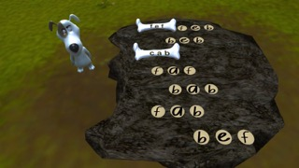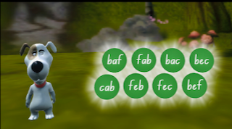

Words in capital letters (uppercase)

FEB BAC BEF FAB BAB BEB FAF BAF BEC FEF CAB FEC

Draw a line to connect the small letters with their capital letters.

a | F
E | c
b | A
C | e
f | B

Capitals!

Children have parents that are bigger, you bet!
It’s the same with the letters of the alphabet.
Each small letter has a parent with it, but the parent looks a little different!
Each big and small letter pair, makes the same sound!
So, if you know the little one, the big sound you’ve found!

Capital letters are for proper nouns, like the days of the week!
And, they’re for the start of a sentence, when you write what you speak.
Capital letters begin the names of people we name, like Bryan and Ryan, and their friend Dane.
Capitals are for the names of months, like August and December.
And for the names of places, we use capitals, remember!

So, here’s the deal. Use capitals for weekdays, whatever you feel!
And, use capitals to start a sentence! For real!
It’s also capitals for the names of places you go, like the city in Norway; it’s called Oslo.
We use capitals for names like, Alice, and Fay!
It’s a capital for April, and months like May!
And use capitals, for street names, where you live, read and play!

So, now you know our very cool gig.
Capitals are the letters big!
The first letter to use, when a sentence you write.
Or, for any weekday, to get it right.
We use capitals too, for the names of all people on earth.
And, we use capitals for months and places, for all that they’re worth.
© georgecanine.com

