LESSONS 3 and 4
Here are the worksheets for Lessons 3 and 4.
Yo, Bro, for practice it gives you lots more.
I truly am your reading pet,
So listen when I tell you this:
The more you practice, the better you get!

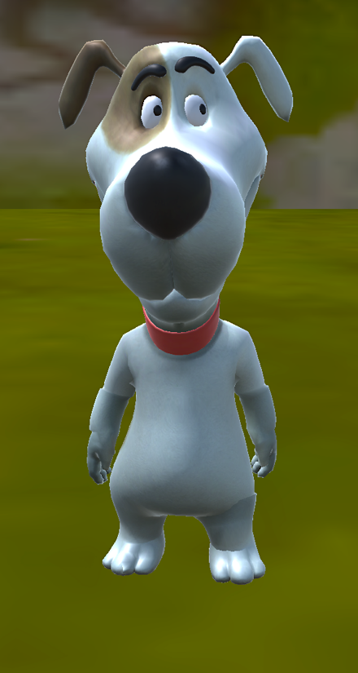

Trace over the letters, i and I
i i i i i i i i i i i i i i i i i i i i i i i
i i i i i i i i i i i i i i i i i i i i i i i i i i i i i i i i i i

Trace over the letters, n and N
n n n n n n n n n n n n n n n n n n n
n n n n n n n n n n n n n n n n n n n n n n n n

Trace over the letters, o and O
o o o o o o o o o o o o o o o o
o o o o o o o o o o o o o o o o o

Trace over the letters, s and S
s s s s s s s s s s s s s s s s s s s s s s s
s s s s s s s s s s s s s s s s s s s s s s s s s s s s

Trace over the lettert, t and T
t t t t t t t t t t t t t t t t t t t t t t t
t t t t t t t t t t t t t t t t t t t t t t t t t t t

Verse for Boogie Bro.

First, N will say a rhyme, then N will say the word for you to spell. So, listen carefully and listen well.

Here is our very first rhyme. Listen carefully, every time!

Is it a fin?
No, it is not! Is it a fan?

No, it is not. It’s neither a fin nor a fan. Not a dot!

Is it a bin?
No, it is not!

Is it a nib?

Is it a, fob?
No, it is not. It is neither a bin nor a nib, nor a fob! Not one bob!

Here’s the rhyme, one more time.
Is it a con? Is it a cob?

No, it is not. It’s neither a con nor a cob! Not a spot!

Now listen to the rhyme for the second last time!

Is it an apple? No, it is not.
Is it a cab?

An apple and a cab it is not!

Now, here’s our rhyme for the very last time:
So, who is so cool and who is real, hip?
It is Olly and Nelly and Izzy, with their Boogie trip.
And you’re very hip and a real whizz!
Because, you have just nailed the writing quiz!

Draw a line to connect the picture with the correct word.

cab
no
an
bin
fan
nib
con
fob
cob

fin

Spell and write the words from Boogie Bro.

Fin no fan bin nib fob cob con an cab fin no fan bin nib fob cob con an cab fin no fan bin nib fob cob con an cab

LESSON 4

Verse for Chase the Cat

N’m a dog, a dude, and a cool bro!
So, N like to chase Carol the cat, you know!
Carol is sometimes not cool with that!
She goes, “That game is just not on, for a cat!”

Carol can be a bit of a snob, for a friendly dog, to so casually fob!
She plays chase often, so of course N sob, when she chooses her other playmate, mob!

Like, N saw Carol once nab Nelly, the newt, up a tree.
And, N saw Carol once chase some fish! About, three!
She grabbed them by their flimsy fins, and threw the poor fish in some bins!

N’ve seen Carol play with an old string net!
And chase a tin can or ten, in the set.
You know, N’ve seen Carol cat chase other dogs, you bet.
First, she bent her back up, as a threat!

Please wait. There's much much more to say,
If N want to chase Carol, every other day:
N’ve seen Carol chase tiny ants with her paw.
And N’ve seen her do a whole lot more.

If the truth be told, she'll chase any rat.
And she’ll chase any fat cat, to scat.
So, no fibs. It is a completely true fact.
Carol plays chase as part of her act!

As N’ve said over again, N love to play “Chase Carol the Cat!” now and then.

If you read the words below, you’ll show Carol why,
She really should, give me a try!

Chase the Cat reading and writing practice

so is not on cat snob to fob sob mob nab bat fins bins an net tin can ten set bet bent as ants if be fat scat no fibs fact act
so is not on cat snob to fob sob mob nab bat fins bins an net tin can ten set bet bent as ants if be fat scat no fibs fact act

Read and write common words
can if of an in no on a to be not at is it so as can if of an in no on a to be not at is it so as can if of an in no on a to be not at is it so as

Answers:
Draw a line to connect the picture with the correct word.

cab
no
an
bin
fan
nib
con
fob
cob

fin

